SW Engineering CSC 648/848

GatorAid: Event Discovery Web Application

Section 6 Team 6

Team Members:

Emely Sarceno Bravo – Team Lead

David Gomez – Front-End Lead

Emerson Berido – Scrum Master

Kelsey Codilla – Back-End Lead

Tavasya Ganpati – GitHub Master

Phong Nguyen – AI Lead

Milestone 2

October 20, 2026

History Table:

Version 1 | September 29, 2026
Version 2 | October 20, 2026

Data Definitions V2
D1 — User
A person who uses GatorAid. A User may browse Events, campus Locations, and use the AI Assistant. Registered Users may also save content, RSVP to Events, and receive personalized recommendations.
Sub-data items:
- user_id — unique identifier for the User
- name — User's display name
- email — User's school email address
- profile_image — optional profile image
  - Supported formats: JPG, JPEG, PNG
  - Maximum size: 5 MB
- interests — categories or topics selected by the User
- saved_content — Events saved by the User
- created_at — date and time the User account was created
- updated_at – date and time the user last edited their profile
User privileges:
- Browse Events
- Search and filter content
- Save Events
- RSVP to Events
- View campus Locations
- Use the AI Assistant
D2 — Host
A Host is a User with permission to create and manage Events.
Sub-data items:
- host_id — identifier associated with the User
- user_id — User account associated with the Host
Host privileges:
- All normal User privileges
- Create Events
- Edit Events they created
- Delete or cancel Events they created
- View RSVP information for their Events
D3 — Event
An Event is a campus activity that Users may discover and attend.
Sub-data items:
- event_id — unique identifier for the Event (events.id)
- title — name of the Event (3–120 characters)
- description — description of the Event (10–5,000 characters)
- host_id — Host responsible for the Event (the User account that created it)
- contact_email — email of the host
- category_ids — the Categories that organize the Event and match the categories Users are interested in (1–7 Categories; see D14)
- start_date_time — starting date and time (time is stored in UTC and displayed in Pacific time)
- end_date_time — ending date and time (must be after the start)
- location_id — associated campus Location
- room_number — optional room or space within the Location (up to 80 characters)
- audience — who the Event is for: All students, Undergraduate, Graduate, First year, or Transfer
- admission_type — free or paid
- rsvp_required — indicates whether Users must register (RSVP) to attend
- registration_deadline — the last day a User can register for an Event (planned)
- capacity — optional maximum number of attendees (1–100,000)
- wheelchair_accessible — indicates whether the Event is wheelchair accessible
- asl_available — indicates whether ASL interpretation is available
- cover_path — optional Event image
- - Supported formats: JPG, JPEG, PNG
- - Maximum size: 5 MB
- - Stored privately and displayed through temporary links
- publication_status — draft or published (only published Events are visible to other Users)
- status — active, cancelled, or completed
- created_at — date and time the Event was created
- updated_at — date and time the Event was last updated
D4 — Location
A Location is a physical place on the SFSU campus where Events happen and that Users can find on the campus map. A Location is a building, an outdoor space, or a venue (a room or facility inside or at a building).
Sub-data items:
- location_id — unique identifier (locations.id, UUID)
- building_name — official name of the Location (unique), e.g. "Cesar Chavez Student Center"
- description — optional additional Location information
- location_kind — building, venue, or outdoor
- building_code — official building code, e.g. "BH" (optional)
- room_suggestions — known room numbers offered when a Host picks a room for an Event
- map_id — short identifier used by the campus map and map links, e.g. "ccsc" (empty if the Location is not on the map)
- map_label — short label displayed on the campus map
- map_category — the Location Category the place belongs to (references D15)
- parent_id — for venues, the Location they are inside or at, e.g. Jack Adams Hall → Cesar Chavez Student Center
- osm_ids — OpenStreetMap elements that draw the Location's shape on the map
- source_url, room_source_url — official SFSU directory pages the Location data comes from
D5 — Location Category
A Location Category groups campus Locations by type, so Users can find places by what they're for. It's different from D7 Category, which organizes Events.
Sub-data items:
- location_category_id — unique identifier (location_categories.id), e.g. "academic"
- label — display name
- sort_order — order shown in the campus map's "Find a place" menu
D6 — RSVP
An RSVP represents a User's response to an Event.
Sub-data items:
- rsvp_id — unique identifier
- user_id — User submitting the RSVP
- event_id — associated Event
- status — attending, interested, or not attending
- created_at — date and time the RSVP was submitted
- updated_at — date and time the RSVP was last changed
D7 — Category
A Category is used to organize and filter Events. Each Category has its own banner color and icon, shown on Events that have no image.
Sub-data items:
- category_id — unique identifier (categories.id)
- name — Category name (unique)
Current Categories:
- Academic
- Career
- Social
- Sports
- Technology
- Student Life
- Health and Wellness
D8 — Saved Content
Saved Content represents an Event bookmarked by a User.
Sub-data items:
- saved_content_id — unique identifier
- user_id — User who saved the content
- content_type — Event
- content_id — identifier of the saved Event
- saved_at — date and time the content was saved
D9 — User Interest
A User Interest represents a topic or Category that a User selects to personalize their GatorAid experience.
Sub-data items:
- interest_id — unique identifier
- user_id — associated User
- category_id — associated Category
User Interests may be used to provide personalized Event recommendations.
D10 — Recommendation
A Recommendation is an Event suggested to a User based on their selected interests and application activity.
Sub-data items:
- recommendation_id — unique identifier
- user_id — User receiving the recommendation
- content_type — Event
- content_id — recommended content
- reason — reason the content was recommended
D11 — Notification
A Notification is a message generated by GatorAid to inform a User about relevant Event activity.
Sub-data items:
- notification_id — unique identifier
- user_id — User receiving the Notification
- message — Notification text
- event_id — optional associated Event
- type — reminder, update, cancellation, or other notification type
- read_status — read or unread
- created_at — date and time the Notification was created
D12 — 3D Location
A 3D Location represents a supported campus environment that Users can explore through the application's 3D experience.
Sub-data items:
- 3d_location_id — unique identifier (rooms.id)
- location_id — corresponding campus Location
- room_name — name of the 3D environment
- model_view_path — 3D spatial data generated from the selected campus location
  - Supported format: GLB (binary glTF), scanned with Scaniverse and displayed with Unity
  - Maximum size: 50 MB (current scans are about 13–15 MB)
- scan_date — date the environment was scanned
- has_3d_view — indicates whether the model is currently accessible
The specific 3D file format and maximum file size will depend on the final Scaniverse-to-Unity workflow and will be defined after our team's technical testing.
D13 — AI Assistant Message
An AI Assistant Message represents an interaction between a User and Allison, the GatorAid AI Assistant.
Sub-data items:
- message_id — unique identifier
- user_id — User associated with the interaction
- conversation_id – identifier linking messages belonging to the same conversation
- message_text — text entered by the User or returned by the AI Assistant
- sender — User or AI Assistant
- created_at — date and time the message was created
- related_content — optional Event or Location associated with the response
D14 — Event_Category

Associates Events with Categories, allowing an Event to have multiple categories or tags.
Sub-data items:
- event_id — the Event (events.id)
- category_ids — ordered list of category_id values referencing Category (D7), stored on the Event
  - 1 to 7 Categories per Event
  - The first Category picks the Event's banner when it has no image

Functional Requirements

Priority definitions
- Priority 1 — Must have: Essential for the core application to function.
- Priority 2 — Desired: Important functionality that will be implemented after the Priority 1 requirements are established.
- Priority 3 — Opportunistic: Additional functionality that will be implemented after higher-priority requirements, as development time permits.

R1 — Home Dashboard
Overall Priority: 1
- R1.1 — Quick Navigation: The home page will provide direct access to Explore All Events, Recommended for You, the interactive campus map, and Allison, the AI assistant. Priority: 1 | User Story: US18
- R1.2 — Upcoming Events: The home page will display a selection of upcoming, active events with their titles, dates, times, locations, categories, and relevant tags. Users will be able to select an event to view its details. Priority: 1 | User Stories: US1, US18
- R1.3 — Event and Location Search: Users will be able to search for events and campus locations from the home page and navigate directly to relevant results. Priority: 1 | User Stories: US2, US7, US18
- R1.4 — Popular Events: The home page will display a Popular on Campus section featuring upcoming events ranked by engagement, including views, saves, RSVPs, and registration activity when that data is available. Priority: 3 | User Story: US18

R2 — Browse Content
Overall Priority: 1
- R2.1 — Explore All Events: Users will be able to browse all current and upcoming active events without providing personal preferences. Event listings will display the title, date, time, location, category, and relevant tags. Priority: 1 | User Story: US1
- R2.2 — Search and Filter Events: Users will be able to search events by title, description, topic, or organizer and filter results by date, time, location, category, and tags. Users will be able to combine multiple filters and clear individual filters or all filters. Priority: 1 | User Story: US2
- R2.3 — Admission and Registration Filters: Users will be able to filter events by free admission, paid admission, invitation-only access, and registration requirements. Priority: 2 | User Story: US2
- R2.4 — Event Display Options: Users will be able to switch between list and grid views. Each event card will display its date, time, location, category, and relevant tags. Priority: 3 | User Story: US1
- R2.5 — Sorting Events: Users will be able to sort event listings by soonest, newest, and most popular. Priority: 3 | User Story: US2
- R2.6 — Empty and Error States: When no events match a search or filter, the application will display a message and allow users to adjust their criteria. When event data fails to load, the application will display an error message and a retry option. Priority: 1 | User Stories: US1, US2

R3 — Detailed Content View
Overall Priority: 1
- R3.1 — Event Details: Each event will have a dedicated details page displaying its title, description, organizer, contact information, start and end times, location, categories, admission type, and status. Event images, capacity, registration deadlines, and registration links will appear when provided. Priority: 1 | User Story: US3
- R3.2 — Event Location Details: Users will be able to open an event's location on the interactive campus map. The application will display available building, floor, and room information associated with the event. Priority: 1 | User Stories: US3, US9
- R3.3 — 3D Location Access: Users will be able to open a 3D environment from an event's details page when a corresponding 3D model is available. Priority: 1 | User Stories: US3, US8
- R3.4 — Save Events and RSVP: Signed-in users will be able to save an event independently of their RSVP status and select an RSVP status of Attending, Interested, or Not Attending. Users will be able to update their RSVP. Cancelled or completed events will not accept new Attending RSVPs. Priority: 1 | User Stories: US3, US4
- R3.5 — Registration Access: When an event has an external registration link, users will be able to open that link from the event details page. The application will clearly distinguish event RSVPs from external registration so that users know when additional registration is required. Priority: 2 | User Story: US3
- R3.6 — Event Status: Event details will clearly indicate whether an event is upcoming, ongoing, completed, or cancelled. Cancelled events will display their cancellation status instead of appearing as active events. Priority: 1 | User Story: US3

R4 — Event Management
Overall Priority: 1
- R4.1 — Create Events: Authorized, signed-in organizers will be able to create events by entering a title, description, contact information, start and end times, location, categories, admission type, and registration information. Priority: 1 | User Story: US13
- R4.2 — Event Validation: The application will validate required fields, date and time values, and the relationship between start and end times before saving an event. Optional event images will be limited to JPG, JPEG, and PNG formats, with a maximum file size of 5 MB. Invalid submissions will display clear error messages. Priority: 1 | User Stories: US13, US14
- R4.3 — View and Edit Events: Authorized organizers will be able to view and edit events they own. Updated information will appear on event listings, details pages, and associated campus map views. Organizers will not be able to edit events owned by other organizers. Priority: 1 | User Story: US14
- R4.4 — Cancel and Delete Events: Authorized organizers will be able to cancel or delete their own events after confirming the action. Cancelled events will retain their event information and display a cancellation notice, but will be excluded from active event listings and recommendations. Deleted events will no longer appear in regular user-facing listings. Priority: 2 | User Story: US15
- R4.5 — Registration Analytics: Authorized organizers will be able to view the number of users registered for each event. The organizer dashboard will also display available engagement metrics, including event views, saves, RSVPs, and registration activity. Priority: 1 | User Stories: US13, US14
- R4.6 — Attendee Demographics: Authorized organizers will be able to view aggregate attendee demographics, including the percentage of attendees by academic year and major, when users have provided that information. Priority: 3 | User Story: US13
- R4.7 — Organizer Profiles: Each organizer will have a profile displaying the organizer's name, description, and upcoming active events. Users will be able to open an organizer profile from an associated event. Priority: 3 | User Stories: US13, US14
- R4.8 — Event Change Notifications: When an event is cancelled or its date, time, location, or other important information changes, the application will send email notifications to users who have saved or RSVP'd to the event, subject to their notification preferences. Priority: 3 | User Stories: US14, US15

R5 — Saved Content and Recommendations
Overall Priority: 1
- R5.1 — Save and Manage Events: Signed-in users will be able to save events, view all saved events in one place, and remove events from their saved list. Saving the same event multiple times will not create duplicate entries. Saving an event will not automatically register the user or change their RSVP status. Priority: 2 | User Stories: US4, US16
- R5.2 — Manage Interests: Signed-in users will be able to select, view, and update their interests using available event categories and tags, including Technology, Career, Social, Arts, and Wellness. The application will associate these preferences with the user's account and use them to personalize event recommendations. Priority: 1 | User Stories: US5, US17
- R5.3 — Personalized Recommendations: The Recommended for You section will display upcoming, active events based on the user's selected interests and available schedule information. Users will be able to access personalized recommendations separately from Explore All Events, which will remain available without requiring personal preferences. Priority: 1-2 | User Stories: US5, US17
- R5.4 — Explainable Recommendations: Each personalized recommendation will display a short explanation of why the event matches the user's interests, such as matching categories, relevant tags, or the number of selected interests that align with the event. When schedule information is available, the recommendation will also indicate whether the event fits the user's availability or overlaps with a scheduled class. Priority: 2 | User Stories: US5, US17
- R5.5 — Schedule Conflict Warnings: When an event overlaps with a confirmed class or other saved busy period, the application will display a conflict warning. The warning will not prevent users from viewing, saving, or RSVPing to the event. Users will remain responsible for deciding whether to attend. Priority: 2 | User Stories: US5, US17, proposed US19
- R5.6 — Recommendation Fallback: When no events match a user's interests or availability, the application will explain that no matching recommendations are available and provide access to Explore All Events and interest settings. Priority: 1 | User Stories: US5, US17
- R5.7 — Popularity-Based Discovery: The application will rank popular events using available engagement data, including views, saves, RSVPs, and registration activity. Popularity rankings will provide a general campus-wide view and will remain separate from personalized recommendations. Priority: 3 | User Story: US18
- R5.8 — Student Profile: Signed-in users will be able to view and update their academic year, major, and selected interests through their profile settings. The profile will also provide access to account settings, notification preferences, and the light or dark theme setting. Priority: 2 | User Story: US17
- R5.9 — Calendar View: Signed-in users will be able to view their saved events and events they have RSVP'd to in a calendar interface. When a confirmed class schedule is available, the calendar will display class entries alongside those events so users can evaluate scheduling conflicts. Priority: 2 | User Stories: US4, US5, US16, proposed US19
- R5.10 — Manage Calendar Entries: Users will be able to distinguish saved events from events they have RSVP'd to in their calendar. Removing an event from saved items will not automatically change its RSVP status, and updating an RSVP will not automatically remove the event from saved items. Priority: 2 | User Stories: US4, US16
- R5.11 — Upcoming Event Reminders: Users will be able to configure email reminders for saved events and events they have RSVP'd to. The application will send reminders before the event begins according to the user's notification preferences. Priority: 3 | User Stories: US4, US16
- R5.12 — RSVP History: Signed-in users will be able to view a history of past events they RSVP'd to in a dedicated section of their profile. Cancelled events will remain identifiable in the user's RSVP history. This history will be separate from the user's saved events. Priority: 3

R6 — 2D Campus Map
Overall Priority: 1
- R6.1 — Interactive Campus Map: Users will be able to view a 2D campus map displaying supported campus buildings and event locations. Users will be able to search for buildings and select location markers to view available building, floor, and room information. Priority: 1 | User Stories: US6, US7
- R6.2 — Events by Location: When users select a campus location, the application will display its current and upcoming active events. Users will be able to open an event directly from the location's event list. Priority: 1 | User Story: US9
- R6.3 — Event Location Highlighting: When users open the map from an event details page, the map will highlight the event's location and display the associated building or venue information. Priority: 1 | User Stories: US3, US9
- R6.4 — Location-Based Event Lists: The selected location's event window will organize events into tabs for all events, events the user has RSVP'd to, and events the user has saved. The RSVP and saved tabs will reflect the signed-in user's own activity. Priority: 2 | User Stories: US4, US9
- R6.5 — Map Navigation: Users will be able to pan and zoom the campus map to explore supported locations. Selecting a location marker will display its available details without requiring users to leave the map. Priority: 1 | User Stories: US6, US7
- R6.6 — 3D Location Access: Users will be able to open a corresponding 3D environment from a supported location on the 2D map. Locations without available 3D models will remain accessible through the 2D map. Priority: 1 | User Stories: US6, US8

R7 — 3D Exploration
Overall Priority: 1
- R7.1 — Open 3D Environment: Users will be able to transition from a supported location on the 2D campus map or an event details page to its corresponding 3D environment. The 3D environment will represent the same location selected in the 2D interface. Priority: 1 | User Stories: US8, US9
- R7.2 — 3D Exploration Controls: The 3D environment will provide camera controls that allow users to rotate their view, look around, and explore the available scanned space. Priority: 1 | User Story: US8
- R7.3 — Return to the 2D Map: Users will be able to return to the 2D map from the 3D environment. If a 3D model fails to load, the application will display an error message and keep the associated map location and event details accessible. Priority: 1 | User Stories: US8, US9
- R7.4 — Supported 3D Environment: The initial 3D environment will represent multiple building locations around campus. The application will use the scanned environment prepared through Scaniverse and Unity. Priority: 1 | User Stories: US8, US9

R8 — AI Assistant
Overall Priority: 2
- R8.1 — Campus and Event Questions: Users will be able to ask Allison questions about campus events and locations through text chat. Allison will use available application data to answer questions and provide links to relevant event details or campus locations when possible. Priority: 2 | User Stories: US10, US11
- R8.2 — Event Discovery Through Natural Language: Users will be able to describe the types of events they want to find using natural language, such as “Which events are related to AI?” or “What career events are happening tomorrow?” Allison will identify relevant events using available event information and search criteria. Priority: 2 | User Stories: US10, US11
- R8.3 — Event Summaries and Comparisons: Allison will summarize event information and compare relevant events based on their topics, categories, schedules, locations, and other available details. When users provide their interests and schedule information, Allison will use that information to explain which events best match their preferences and availability. Priority: 2 | User Stories: US5, US10, US11
- R8.4 — Location Assistance and Application Guidance: Allison will help users find event locations and explain how to navigate GatorAid. When information is unavailable, or a question is unclear, Allison will communicate the limitation or ask the user for clarification rather than present unsupported information as fact. Priority: 2 | User Stories: US9, US12
- R8.5 — Interest-Aware AI Responses: When a signed-in user has selected interests, Allison will use those preferences to personalize event discovery and explain why particular events are relevant. Allison will continue to answer general campus and event questions without requiring users to configure interests. Priority: 2 | User Stories: US5, US17

R9 — AI Schedule Scanner
Overall Priority: 2
- R9.1 — Upload Class Schedule: Users will be able to upload an image or screenshot of their class schedule. The application will process the image to extract available class names, days, and start and end times and convert the extracted information into structured schedule entries. Priority: 2 | Proposed User Story: US19
- R9.2 — Review and Correct Extracted Schedule: After schedule extraction, the application will display the extracted classes in an editable timetable. Users will be able to correct inaccurate information, add missing classes, remove incorrect entries, and confirm the schedule before saving it. Priority: 2 | Proposed User Story: US19
- R9.3 — Save and Manage Class Schedule: After users confirm their schedule, the application will save the structured class entries and associate them with the corresponding user account. Users will be able to view and update their saved schedules. Schedule information will be stored separately from general profile information in the database and will only be accessible to authorized users and application functions. Priority: 2 | Proposed User Story: US19
- R9.4 — Schedule-Aware Event Discovery: The application will compare confirmed class times against event start and end times to identify potential conflicts and periods of availability. The application will use the results alongside selected interests to inform personalized recommendations and conflict warnings. Schedule conflicts will not prevent users from saving or RSVPing to events. Priority: 2 | Proposed User Stories: US5, US17, US19
- R9.5 — AI Error Handling: When Allison cannot retrieve relevant event or campus information, the application will communicate that the information is unavailable and provide an alternative way to browse the relevant content. When schedule extraction fails, the application will display an error and allow users to retry or enter their schedule manually. Priority: 2 | User Stories: US10, US11, US19

R10 — Calendar View
Overall Priority: 2
- R10.1 — Calendar Display: Signed-in users will be able to view their saved events and events they have RSVP'd to in a calendar organized by date. Users will be able to navigate between calendar periods and select an event to open its details.
Priority: 2 | User Stories: US4, US16
- R10.2 — Class Schedule Integration: When a user has saved a confirmed class schedule, the calendar will display class entries alongside saved, RSVP'd, and cancelled events so users can identify potential scheduling conflicts.
Priority: 2 | Proposed User Story: US19
- R10.3 — Event Status Display: The calendar will visually distinguish cancelled events from active and completed events. Cancelled, Saved, and RSVP’d events will use a distinct color or visual indicator so users can identify them easily.
Priority: 2 | User Stories: US3, US15
- R10.4 — Calendar Display Filters: Users will be able to choose which events appear on their calendar by filtering between RSVP'd events, saved events, and cancelled events. Users will be able to display any individual category or any combination of categories, including all categories. Users will also be able to clear their selections to restore the default calendar view.
Priority: 2 | User Stories: US4, US15, US16
- R10.5 — Calendar Event Details: Users will be able to select an event on the calendar to view its title, date, time, location, RSVP status, and current event status when available.
Priority: 2 | User Stories: US3, US4
- R10.6 — Independent Event Categories: The calendar will distinguish saved events from RSVP'd events. An event that is both saved and RSVP'd will appear when either applicable category is selected, without creating duplicate calendar entries. Changing calendar display filters will not modify the user's saved events or RSVP status.
Priority: 2 | User Stories: US4, US16
- R10.7 — Cancelled Event Visibility: Users will be able to hide cancelled events from the calendar without removing them from their RSVP history or saved events. When cancelled events are hidden, they will not appear in the calendar until the user enables the cancelled-events filter again.
Priority: 2 | User Stories: US4, US15, US16

R11 - Notifications and Notification Settings
Overall Priority: 3
- R11.1 — Event Cancellation Notifications: The application will notify users who have saved or RSVP'd to an event when that event is cancelled.
Priority: 3 | User Stories: US4, US15
- R11.2 — Event Update Notifications: The application will notify users who have saved or RSVP'd to an event when its date, time, location, or other important information changes. Notifications will identify the relevant update.
Priority: 3 | User Stories: US4, US14
- R11.3 — Upcoming Event Reminders: Users will receive reminders before events they have saved or RSVP'd to, according to their notification settings.
Priority: 3 | User Stories: US4, US16
- R11.4 — Notification Settings: Signed-in users will be able to access notification settings and independently enable or disable notifications for event cancellations, event updates, and upcoming event reminders. The application will apply the user's saved preferences when sending notifications.
Priority: 3 | User Story: US17
- R11.5 — Notification Delivery Preferences: Users will be able to select the supported notification delivery methods. Email notifications will be supported, and any additional delivery method will be available only when implemented.
Priority: 3 | User Story: US17
- R11.6 — Notification Accuracy: The application will send notifications only for applicable event changes and reminders. Cancelled events will not generate standard upcoming-event reminders after cancellation.
Priority: 3 | User Stories: US14, US15, US16

R12 — User Authentication and Account Management
Overall Priority: 1
- R12.1 — Create Account: New users will be able to create an account by providing the required information, including their name, email address, and password. The application will validate the submitted information and prevent account creation when required fields are missing or the email address is already registered. Priority: 1
- R12.2 — Email Verification: After creating an account, users will receive a verification email containing a verification link. Users will be able to verify their email address by following the link. The application will display a confirmation message when verification succeeds and an appropriate error message when the link is invalid or expired. Priority: 1
- R12.3 — Log In: Registered users will be able to log in using their email address and password. The application will authenticate their credentials and provide access to the appropriate signed-in features when authentication succeeds. Priority: 1
- R12.4 — Incorrect Login Credentials: When a user enters an incorrect email address or password, the application will display an error message indicating that the credentials are invalid. Priority: 1
- R12.5 — Log Out: Signed-in users will be able to log out through the application interface. Logging out will end their authenticated session and return them to a signed-out state. Protected account information and features will require authentication again. Priority: 1
- R12.6 — Unverified Email Restrictions: Users who have not verified their email addresses will be prompted to complete email verification. The application will enforce its email verification requirements before granting access to features that require a verified account. Users will be able to request another verification email. Priority: 1
- R12.7 — Password Visibility: Users will be able to show or hide their password while entering it on the account creation and login forms. Priority: 2
- R12.8 — Password Strength and Validation: During account creation, the application will validate passwords against its defined password requirements and display clear guidance when a password does not meet those requirements. Priority: 2
- R.12.9 — Password Reset: The system will allow users who forget their passwords to request a password-reset email and securely create a new password through a valid reset link. Priority: 2
- R12.10 — Session Persistence: After logging in successfully, users will remain signed in when navigating between application pages until they log out or their session expires. Priority: 1
- R12.11 — Duplicate Account Handling: When a user attempts to register with an email address that is already associated with an account, the application will display an appropriate message and direct the user to the login process.
Priority: 1

UI Mockups and UX Flows

Figma file: UX Prototypes for High-Priority Features
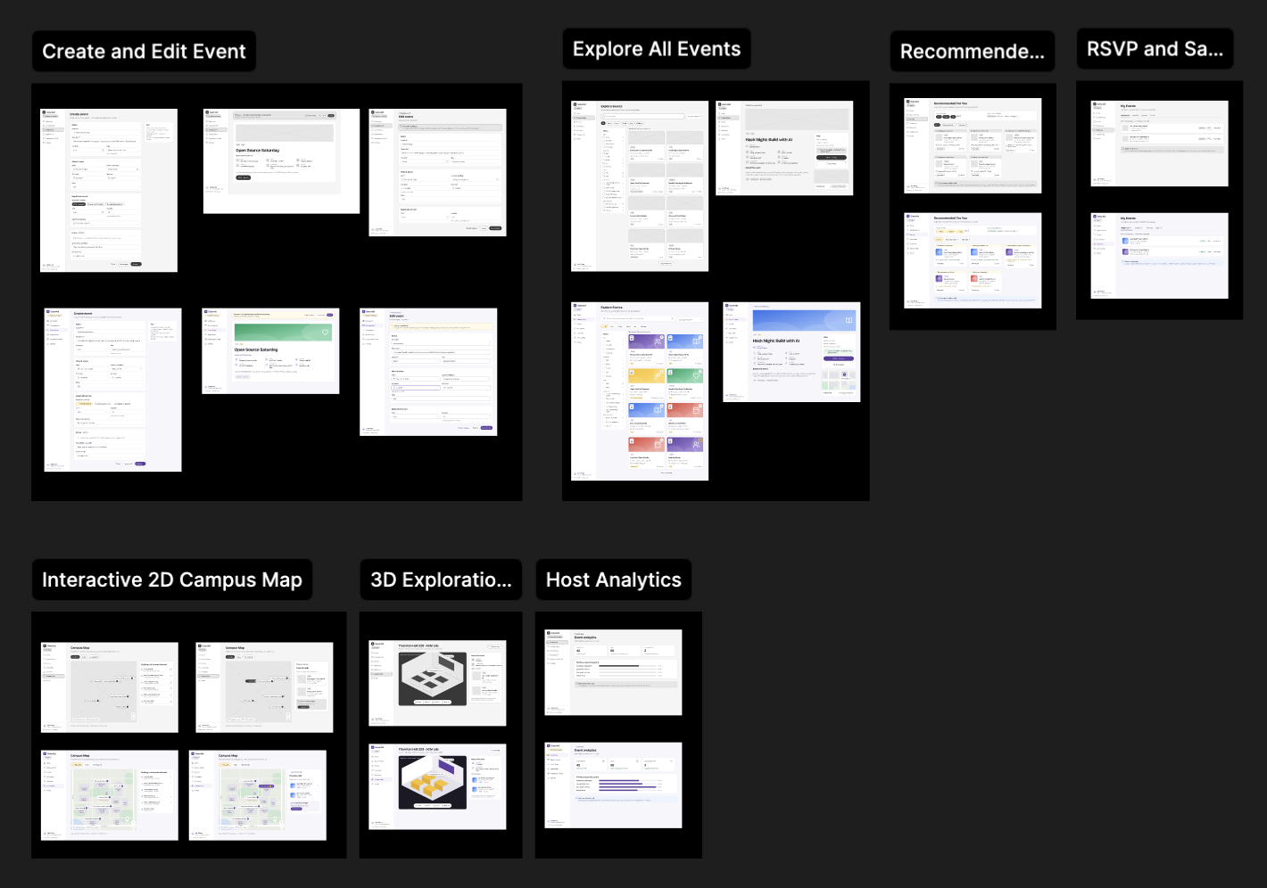
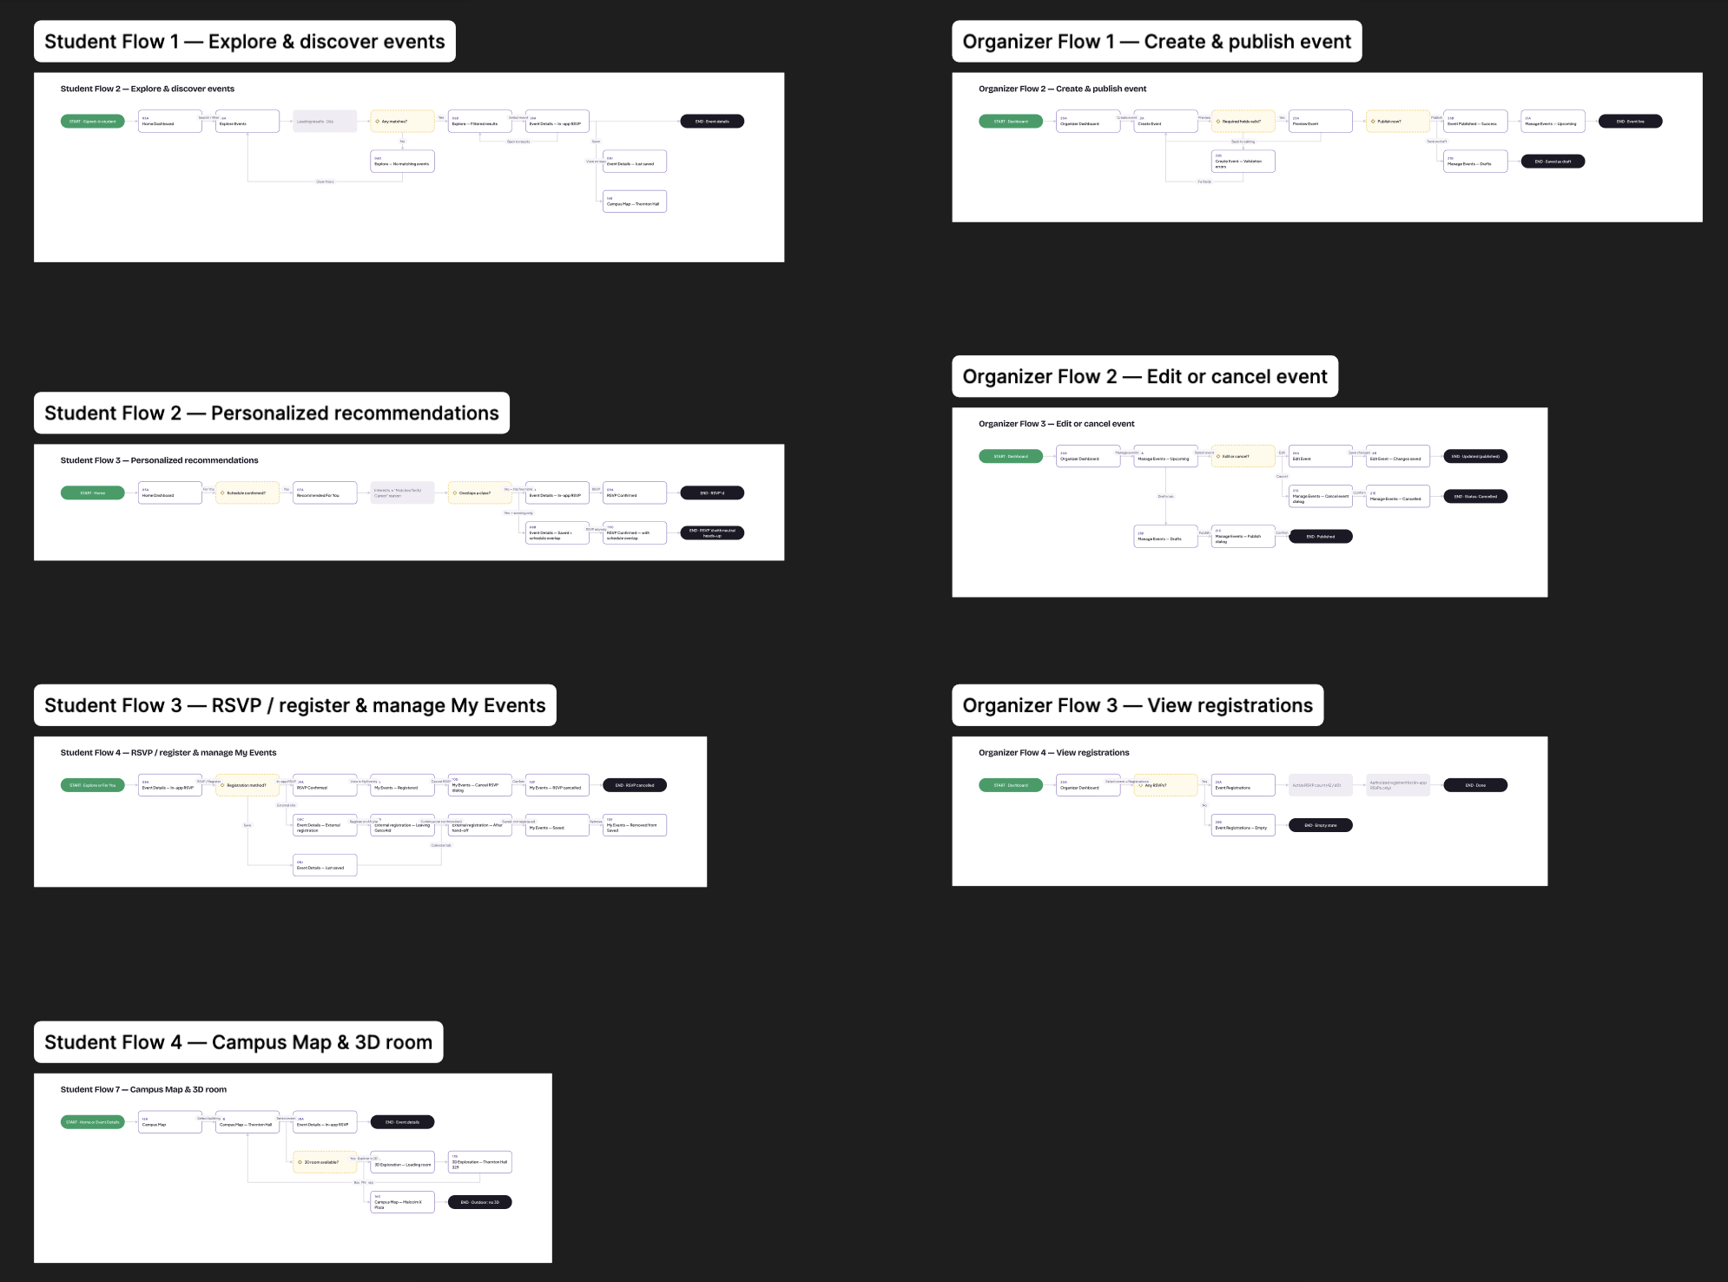
This Figma file holds the UX prototypes for GatorAid’s highest priority features. Each feature has its own frame, which contains a pair of black-and-white wireframe, labeled “WF”, with a high-fidelity mockup of the same screen. The wireframes focus on screen layout, available actions and how one screen leads to the next, not on visual style. Together, the screens trace complete user flows for two user types: a student and a host. All screens use sample data and are designed at desktop size.

Prototype section | Screens | User stories covered
Explore All Events | Explore Events, Event Details, RSVP | US1, US2, US3, US18
Interactive 2D Campus Map | Campus Map, Campus Map with Thornton Hall Selected | US6, US7, US9
3D Exploration | 3D View of Thornton Hall | US8
Create and Edit Events | Create Event, Preview Event, Edit Event | US13, US14
RSVP and Saved Events | My Events (Registered, Saved, and Past) | US4, US16
Host Analytics | Event analytics for multiple events | US13, US14
Recommended For You | Recommendations based on interests | US5, US17

UX Flows

- Student Flow 1: Explore and discover events (US1, US2, US3, US4, US9)
- A signed-in student starts on the Home Dashboard and opens Explore Events.
- They search or apply filters, and the results load.
- Decision: Are there any matches?
  - Yes: the filtered results appear, and the student selects an event to open Event Details.
  - No: a "No matching events" message appears, and the student can clear the filters to start again.
- From Event Details, the student can save the event (it then shows "Just saved"), choose View on map to see the building on the Campus Map, or go back to the results.

- Student Flow 2: Personalized recommendations (US5, US17)
- From the Home Dashboard, the student opens For You.
- Decision: Has the student confirmed their interests?
  - If yes, recommendations take them into account.
  - If not, recommendations do not take them into account.
- Recommended For You lists events matched to the student's interests, each with a reason such as "Matches your interest: Tech".

- Student Flow 3: RSVP or register, and manage My Events (US4, US16)
- The student starts from Explore or For You and opens Event Details.
- Decision: What is the event's registration method?
  - In-app RSVP: the student RSVPs, sees RSVP Confirmed, and the event appears under My Events → Registered. They can cancel the RSVP, confirm in a dialog, and see that the RSVP was cancelled.
  - External site: GatorAid shows that the student is leaving the app to register on another site, such as the Associated Students site. When they return, GatorAid doesn't record a confirmation, so the event stays saved, not registered.
- A saved event appears under My Events → Saved, where the student can remove it.

- Student Flow 4: Campus Map and 3D room (US6, US7, US8, US9)
- The student starts from Home or Event Details and opens the Campus Map.
- They select a building, such as Thornton Hall, to see its upcoming events, and they can select an event to open its details.
- Decision: Does the place have a 3D room?
  - Yes: the student chooses Explore in 3D. The room loads, they explore Thornton Hall 329, and Back to map returns them to the map.
  - No: outdoor spaces such as Malcolm X Plaza show their events but have no 3D view.

- Host Flow 1: Create and publish an event (US13)
- The host starts on the Host Dashboard and opens Create Event.
- Decision: Are the required fields valid?
  - No: validation errors appear next to the fields, and the host fixes them.
  - Yes: the host opens Preview Event to see the event exactly as students will.
- Decision: Publish now?
  - Yes: the host publishes, sees a success message, and the event appears under Manage Events → Upcoming. The event is now live.
  - No: the host saves the event as a draft, and it appears under Manage Events → Drafts. They can also go back to editing.

- Host Flow 2: Edit or cancel an event (US14, US15)
- From the Host Dashboard, the host opens Manage Events and selects an event.
- Decision: Edit or cancel?
  - Edit: the host updates the event in Edit Event and saves. A confirmation shows that the changes were saved, and the event stays published.
  - Cancel: the host confirms in a dialog, and the event's status changes to Cancelled.
- From the Drafts tab, the host can also publish a draft after confirming in a dialog.

- Host Flow 3: View registrations (US13, US14)
  - From the Host Dashboard, the host selects an event and opens its Registrations.
  - Decision: Are there any RSVPs?
    - Yes: Event Registrations shows the active RSVP count against capacity (for example, 42 / 60) and the list of students who RSVP'd in the app. Only the event's host can see this list.
    - No: an empty state explains that no one has RSVP'd yet.

UX Principles Review

- Useful
  - Each screen supports a high-priority user story from Milestone 1.
  - Event information, location, 3D preview and registration are combined in one place, which addresses the pain point that campus information is spread across many websites.
  - Organizers get the information they need: how many students RSVP'd and saved their event.
  - Recommendations take the student's class schedule into account, so they mostly suggest events the student can actually attend.

- Usable
  - A sidebar shows the same main sections on every student screen, and the organizer workspace has its own sidebar.
  - Filters show how many events match each option, so students know the result before they choose.
  - The Create Event form groups fields into sections, marks required fields, and includes hints such as "Leave blank for unlimited."
  - Errors are prevented before they happen: capacity can't be set below the current RSVP count, edited fields show their old value, and organizers can preview an event before publishing it.
  - Every screen in a flow has a clear way back, such as "Back to Explore Events", "Back to map" and "Back to editing".

- Desirable
  - The layout is clean and consistent, with cards, labels, and social proof such as "42 going" and "18 spots left".
  - The 3D room view lets students see a room before they visit it in person.
  - The wireframes are black and white, so feedback stays on layout and flow. Visual styling is limited to the higher-fidelity mockups.

- Accessible
  - Every event and room shows accessibility information, for example "Wheelchair accessible · ASL on request" or "Step-free entrance · elevator to 3rd floor".
  - The 3D view has rotate, zoom and reset buttons, so it doesn't rely only on dragging, along with text instructions.
  - Information is conveyed with text labels as well as color, for example "Building with events" and "3D room available" in the map legend, and "Full · 60/60" for status.
  - The organizer form includes a field for accessibility information, so hosts are prompted to provide it.

- Findable
  - Students can find events through search, filters and category chips, the campus map, and For You recommendations.
  - The map links events to buildings, and event details link back to the map and the 3D view.
  - My Events keeps registered, saved and past events in one place.
  - Results show a count ("Showing 8 of 48 upcoming events") and a clear sort order ("Soonest first").

- Credible
  - Each event shows who is hosting it and a contact email.
  - Only published, upcoming events are shown to students, and organizers see a clear notice when an event is still a draft.
  - Host analytics show only totals (RSVPs, saves and cancellations), never which students RSVP'd or saved.

High level Architecture, Database Organization

Database Organization
GatorAid uses Supabase, a hosted PostgreSQL database.
Users (D1)
Database name : auth.users (Supabase Authentication)
UID | uuid (PK)
Display name | text
Email | varchar(255)
Phone | text
Providers | jsonb
Provider type | text
Created at | timestamptz
Last sign in at | timestamptz

Hosts (D2)
Database name : hosts
user_id | uuid (PK / FK → users.id)
display_name | text
created_at | timestamptz

Events (D3)
Database name: events
id | uuid (PK)
host_id | uuid (FK → hosts.id)
title | text
description | text
start_date_time | timestamptz
end_date_time | timestamptz
location_id | uuid (FK → locations.id)
room_number | text
category_ids | uuid[] (FK → categories.id)
contact_email | text
admissions_type | text
capacity | int4
audience | text
rsvp_required | bool
wheelchair_accessible | bool
asl_available | bool
cover_path | text
publication_status | text
status | text
created_at | timestamptz
updated_at | timestamptz

Categories (D7)
Database name: categories
id | uuid (PK)
name | text

Locations (D5)
Database name: locations
id | uuid (PK)
building_name | Text, unique
description | text
location_kind | text
building_code | text
room_suggestions | text[]
source_url | text
room_source_url | text
map_id | text
map_label | text
map_category | text, FK → Location Categories.id
parent_id | uuid, FK → Locations.id
osm_ids | text[]

Location Categories (D15)
Database name: location_categories
id | uuid (PK)
label | text
sort_order | int4

3D Location (D12)
Database name: rooms
id | uuid (int8, PK)
room_name | varchar
has_3d_view | bool
model_view_path | varchar
scan_date | date
location_id | uuid, FK → Locations.id

File Storage
Supabase Storage buckets
event-covers | private; Event images
events.cover_path | JPG, JPEG, PNG; max 5 MB; shown through temporary links
rooms | public; 3D scans (rooms.model_view_path); GLB; max 50MB

Relationships
- A User hosts many Events (events.host_id).
- A Location has many Events (events.location_id) and 3D Location(s) (rooms.location_id).
- A Location can contain venues: other Locations whose parent_id points to it (for example, Jack Adams Hall inside the Cesar Chavez Student Center).
- A Location Category groups many Locations (locations.map_category).
- An Event has 1–7 Categories (events.category_ids).
Access rules (Row Level Security)
- Anyone can read Categories, Locations, Location Categories, 3D Locations and published Events.
- Draft Events are visible only to their Host.
- Only the Host can update or delete their own Events and images.

Add / Delete / Search Architecture
Table | Operation | Who | Data fields involved
Users | Add (sign up) | Anyone | email, password
Users | Sign in / sign out | Users | email, password
Users | Display | Everyone (as the Event host's name) | display_name (or the email prefix)
Users | Update / delete  (not yet implemented) | Any signed-in User (their own account) | display_name, email
Events | Add (save draft) | Any signed-in User (becomes the Host) | title, description, start_date_time, end_date_time, location_id, room_number, category_ids, contact_email, admission_type, capacity, audience, rsvp_required, wheelchair_accessible, asl_available, cover_path
Events | Update (edit) | Host of that Event | same fields as Add
Events | Update (publish) | Host of that Event | publication_status (draft → published)
Events | Delete | Host of that Event | id (also deletes its cover image)
Events | Search (Explore page) | Everyone | keyword in title, description, building_name or Category name; filter by Category, date (start_date_time) and building_name
Events | Search (Campus Map) | Everyone | filter by date range (today / this week / upcoming), Category, and building (location_id)
Events | Display | Everyone (published Events); Host (also their drafts) | all Event fields, plus building_name and the Host's name
Categories | Display | Everyone | name
Categories | Search / filter | Everyone | name (Events by Category)
Categories | Add / update / delete | Team only, through database migrations | name
Locations | Display | Everyone | building_name, description, building_code, map_label, room_suggestions
Locations | Search | Everyone | building_name or building_code (Event form); "Find a place" menu on the Campus Map, grouped by map_category
Locations | Add / update / delete | Team only, through database migrations | all Location fields
Location Categories | Display | Everyone | label, sort_order
Location Categories | Add / update / delete | Team only, through database migrations | id, label, sort_order
3D Locations | Display | Everyone | room_name, scan_date, model_view_path
3D Locations | Search | Everyone | by Location (location_id), on the Campus Map and Event pages
3D Locations | Add / update / delete | Team only, through migrations and Storage | all 3D Location fields
File Storage | Add (upload image) | Signed-in User | image file (JPG, JPEG, PNG; max 5 MB)
File Storage | Delete | Host, when deleting an Event | cover_path

APIs

Backend Endpoint APIs
Next.js route handlers in app/api/ that the frontend and other clients call.
Method and endpoint | Purpose | Sign-in | Request | Response
GET /api/events | List published, active Events | No | none | { events }
GET /api/events/:eventId | One published Event | No | eventId | { event }, or 404
GET /api/host/events | List the signed-in Host's Events, including drafts | Yes | none | { events }
POST /api/host/events | Create a draft Event | Yes | Event fields (D3) | { event }, or 422 with field errors
GET /api/host/events/:eventId | One of the Host's own Events | Yes (owner) | eventId | { event }, or 404
PATCH /api/host/events/:eventId | Update the Host's Event | Yes (owner) | Event fields | { event }, or 422
DELETE /api/host/events/:eventId | Delete the Host's Event and its image | Yes (owner) | eventId | { deleted: true }
POST /api/host/events/:eventId/publish | Validate and publish a draft | Yes (owner) | eventId | { event }
GET /api/locations | List all campus Locations | No | none | { locations }
GET /api/locations/:locationId | One Location and the venues inside it | No | locationId | { location, venues }, or 404
GET /api/locations/:locationId/events | Upcoming published Events at a Location and its venues | No | locationId | { events }, or 404
GET /api/rooms/:roomId/info | 3D Location name and scan date | No | roomId | { room_name, scan_date }, or 404
GET /api/rooms/:roomId/3d-model | The 3D Location's GLB file | No | roomId | GLB file (model/gltf-binary), or 404
POST /api/users/me/schedule/scan | AI schedule scanner: reads a class schedule image | No (planned: Yes) | schedule image | the classes found in the image
Common rules
- Responses are JSON. Errors return { error } with 401 (sign in required), 403 (invalid request origin), 404 (not found), 422 (invalid fields) or 503 (database unavailable).
- Host actions check sign-in and ownership in the API, and again in the database (Row Level Security).
- Page loads read the database directly on the server (Next.js Server Components, under the same Supabase rules). The API routes handle browser actions, such as saving, publishing and deleting Events, and other clients.
Supabase client APIs used directly by the frontend
- Supabase Auth: sign up, sign in, sign out, current session.
- Supabase Storage: upload an Event image to event-covers, and create temporary image links.

Third-Party APIs and Services
Service | What we use it for
Supabase | PostgreSQL database, authentication, file storage and Row Level Security (@supabase/supabase-js, @supabase/ssr)
Google Gemini API (@google/genai, model gemini-3.8-flash) | AI schedule scanner: reads classes from an uploaded schedule image
Scaniverse (Niantic) | Scanning campus rooms into 3D models (GLB files)
Unity WebGL | Displaying 3D Locations in the browser, with W, A, S, D navigation
OpenStreetMap data | Campus building outlines, roads and paths for the 2D Campus Map (© OpenStreetMap contributors, ODbL licence), converted to SVG by our build script

Open-Source Components
Component | Use
Next.js 16 (App Router) and React 19 | Web framework: pages, server rendering, API routes
Tailwind CSS 4 | Styling
Lucide React | Icons
ESLint (with eslint-config-next) | Code linting
Node.js test runner (node:test) | Unit tests

Changes to Software Tools and Frameworks
- Added: Google Gemini API for the AI schedule scanner.
- Added: Unity WebGL with Scaniverse scans for the 3D experience, instead of three.js.
- Added: OpenStreetMap data for the 2D Campus Map, drawn as our own SVG. No maps API key is needed.
- Supabase for database, authentication and storage.

High-Level UML Diagrams

High-Level UML Class Diagrams
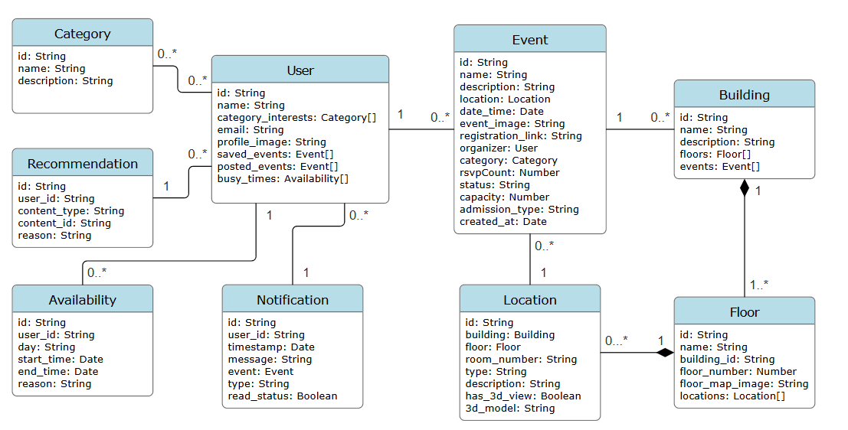

High-Level Sequence Diagrams

Explore All Events
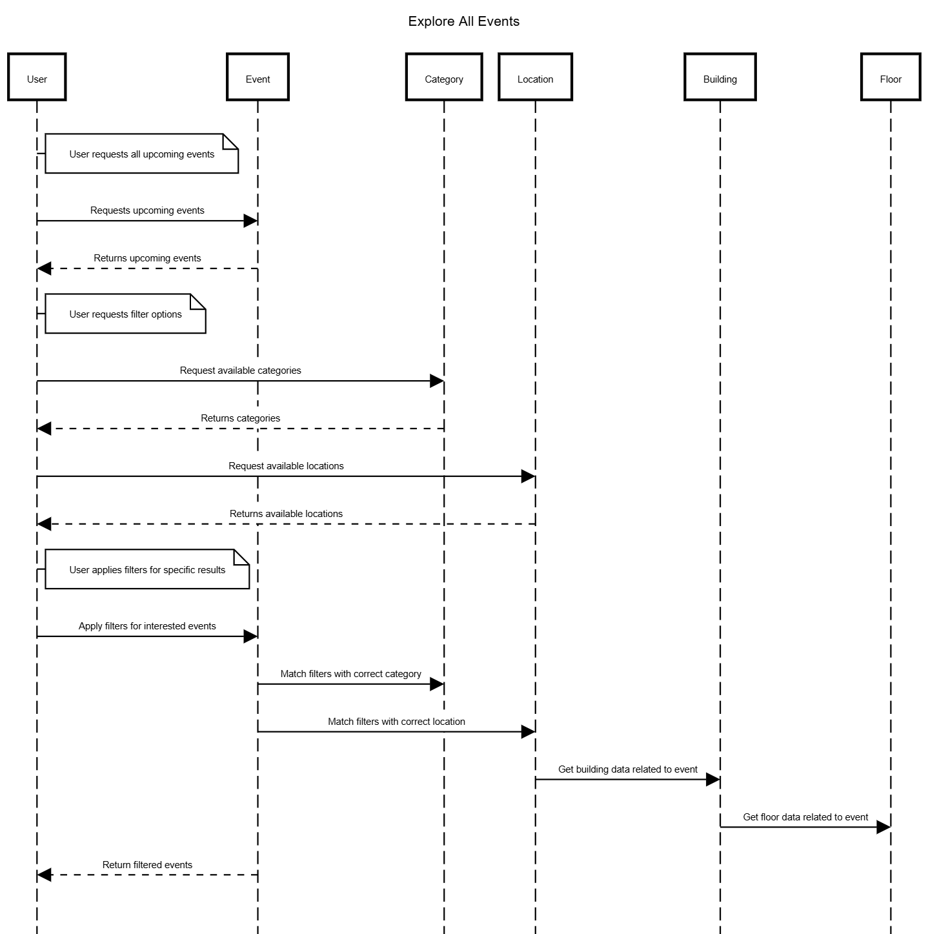

Recommended For You
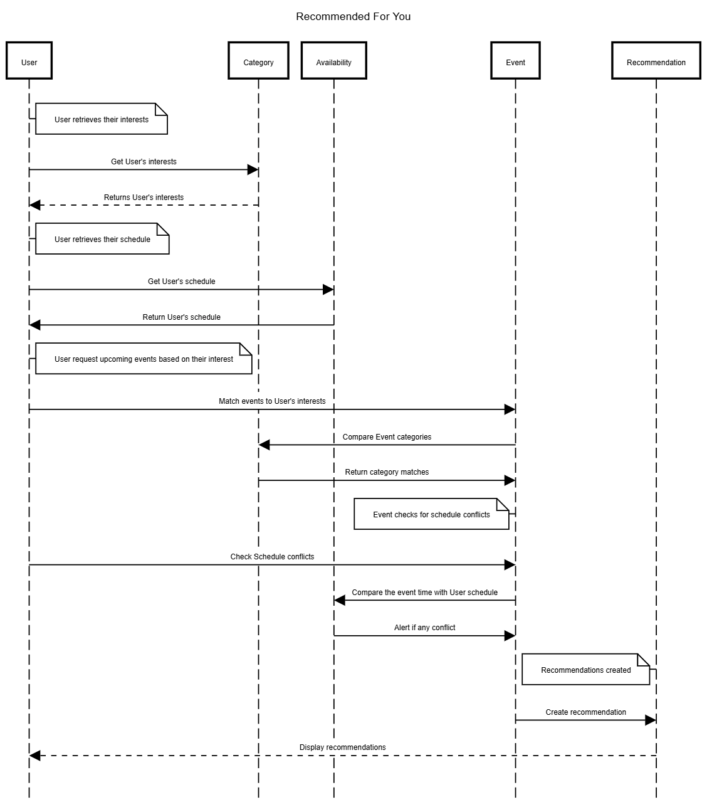

AI Schedule Scanner
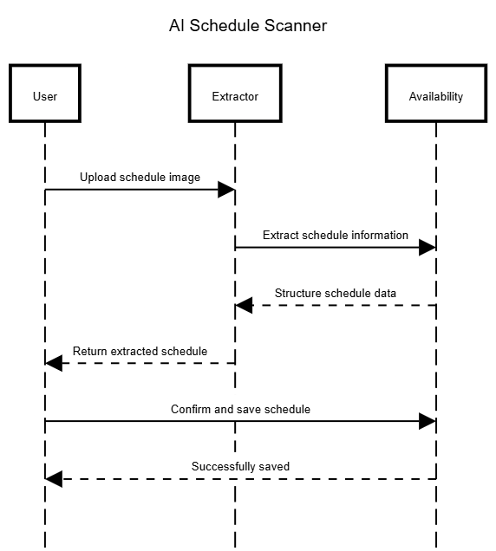

AI Assistant
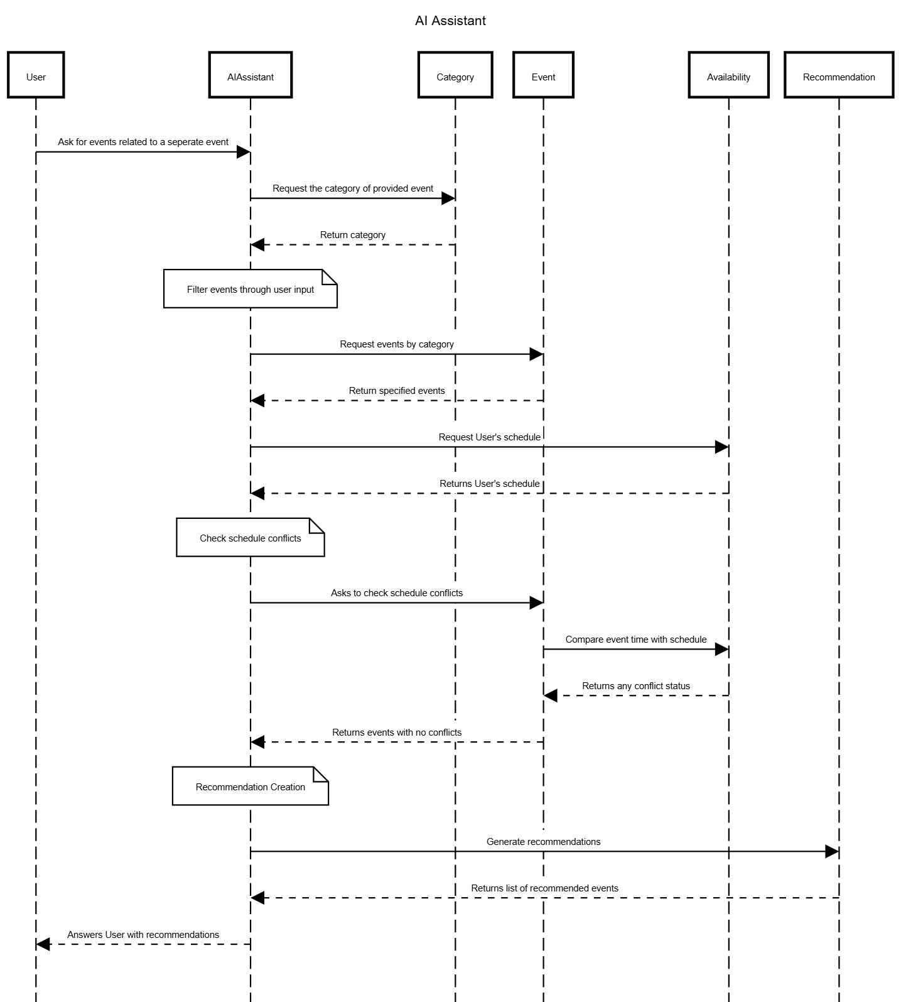

Interactive 2D Campus Map
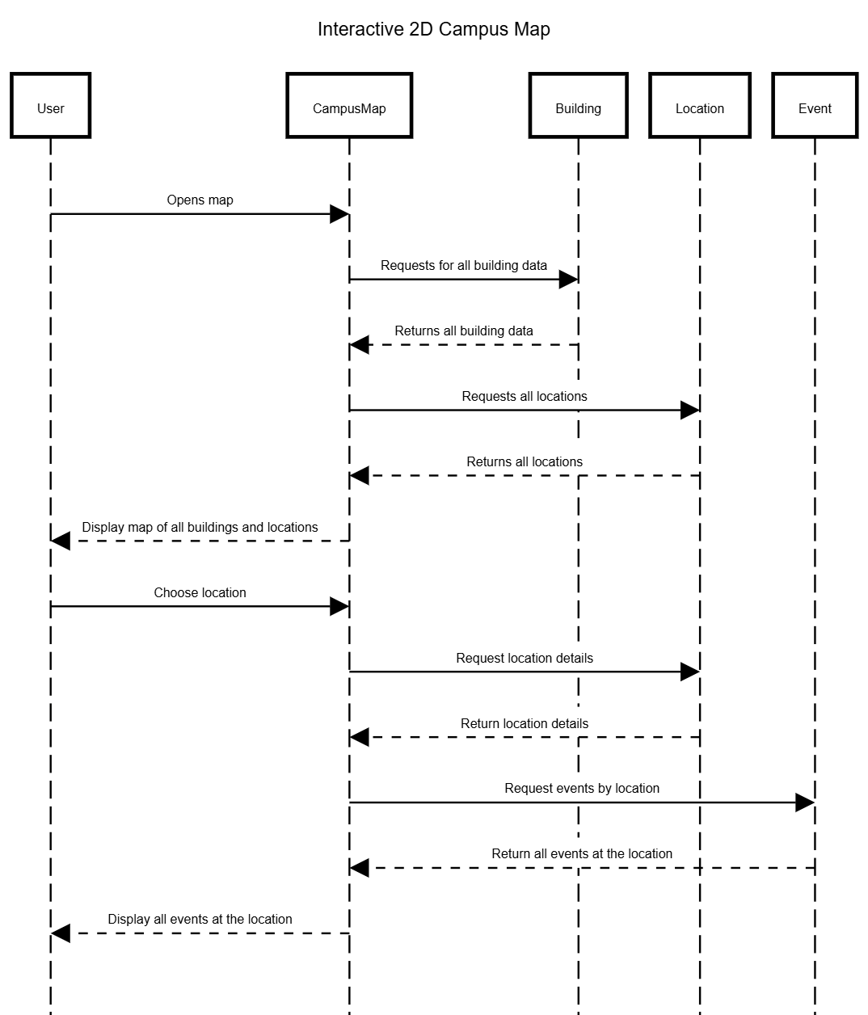

3D Campus & Event Exploration
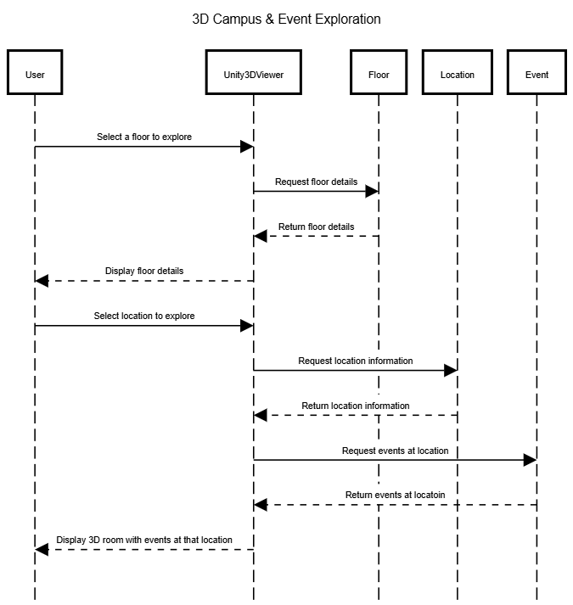

,

Key Risks

Skills risks and mitigation plan: Our team has been following our study plan that covers all the technologies used in the project and every member has been following it. We don't see skills as a major risk, but we identified the following potential risks and how we address them.
- Risk 1: A team member may struggle to understand a technology or concept needed for their task, such as Next.js, Supabase or the database design.
  - Mitigation: Team members are encouraged to ask questions as soon as they come up, either in our Discord server or during our Scrum meetings. When someone finds a topic challenging, the teammate most familiar with it walks them through it. This way, everyone keeps learning and no one stays stuck for long.
- Risk 2: Knowledge of a feature may be concentrated in one person, which makes it harder for others to understand or support that part of the project.
  - Mitigation: We share knowledge openly through our study plan, Discord discussions and Scrum meetings, where members explain what they are working on. Helping each other is part of how our team works, so knowledge spreads naturally and more than one person understands each part of the application.

Schedule risks: Our team has a schedule in Jira that lists every member's detailed tasks. Each member knows exactly what they are responsible for and what is expected of them. Changes are shared with the team immediately, so the schedule stays transparent and up to date.
- Risk 3: A change to a task, such as a new requirement, a delay or a reassignment, could put other tasks or a project deadline at risk.
  - Mitigation: Any change is shared with the team right away and updated in Jira, so everyone can see the current status of every task. Since changes are communicated immediately, we can adjust quickly and keep up with our tasks and project deadlines.
- Risk 4: One team member's task may depend on another member's work. For example, a page may need a database table or an API endpoint to be finished first.
  - Mitigation: Dependencies between tasks are recorded in our Jira schedule and discussed during our Scrum meetings. Every member knows which tasks they are waiting on and which tasks depend on their work, so dependent work can be planned in the right order.

Teamwork risks: All members attend meetings regularly, keep their pace on assigned tasks, and ask for help when needed. Tasks are tracked in Jira. We do not see any risks regarding attendance or pace.
- Risk 5: A team member may occasionally be unable to attend a meeting because of a class, work or personal conflict, and miss decisions or updates.
  - Mitigation: Any member who can't attend lets the team know ahead of time in Discord. Meeting decisions and task updates are posted in Discord and reflected in Jira, so the member can catch up afterward. They also share their own progress in Discord, so the rest of the team stays informed.
- Risk 6: A team member may fall behind on a task. For example, during a busy week of exams or when a task turns out to be harder than expected.
  - Mitigation: We check progress during our Scrum meetings and through Jira, so a slowdown is noticed early. The member is encouraged to speak up as soon as they're behind, and teammates offer help or temporarily take on part of the work. If needed, we adjust the timeline in Jira so we still meet the project deadline.

Legal/content risks (can you obtain content/SW you need legally with proper licensing, copyright) How do you plan to resolve each problem Identify the risk and explain in 2-3 lines how you will address them
- Risk 7: Campus map data and SFSU sources
  - Description: The 2D Campus Map is drawn from OpenStreetMap (OSM) data. OSM's ODbL licence requires credit, and requires sharing any database we derive from it under the same licence. Building names, codes and rooms come from SFSU's public directories, and the official SFSU campus map was used only to check building names. Copying SFSU's map image or logo without permission would infringe their copyright.
  - Mitigation:
    - We show "© OpenStreetMap contributors" on the map.
    - Our generated map data (lib/map/geometry.js) is marked as ODbL-licensed and stays openly available in our repository.
    - We draw our own map from OSM data and never copy SFSU's map images or logos. Every location keeps a link to its official SFSU source.
- Risk 8: Room scans and software licences.
  - Description: 3D scans capture interiors of campus buildings, and the app relies on third-party software and services (Unity, Supabase, open-source libraries).
  - Mitigation:
    - We only scan public campus spaces, and will confirm with the instructor or the building's office before publishing any non-public room.
    - Unity is used under its free Personal licence, and all libraries we use are open source (MIT/ISC). We'll keep a licence list in the repo.
- Risk 9: AI processing of student schedules.
  - Description: The AI schedule scanner sends uploaded schedule images to Google Gemini. These images can contain personal data such as names, student IDs and class lists. On the free tier, Google's terms allow it to use submitted content to improve its products. AI results can also be wrong, for example a misread class time.
  - Mitigation:
    - The scanner will tell users their image is processed by Google AI, recommend cropping out personal details, and never store the image.
    - Users review and edit the extracted classes before saving.
    - The API key stays private on the server. The scanner will require sign-in, and we'll move to a paid tier, where data isn't used for training, if we deploy publicly.

Project Management

Our team managed M2 tasks with Jira. Each M2 requirement was split into smaller tasks. Every task was assigned to one member with a due date and tracked on our Jira board (To Do → In Progress → In Review → Done). When plans changed, the task's status, owner or date was updated in Jira, so the whole team always saw the current state.

We hold scrum meetings twice a week: on Tuesdays and Sundays. Each member shares what they finished, what they're working on next, and anything blocking them, using the Jira board as the agenda, so progress is visible to everyone. Blockers are discussed right away. Members who need help understanding a technology ask questions and share learning resources, and we follow a shared study plan to keep everyone's skills on track.

Code progress is also transparent on GitHub. Each member works on their own feature branch and merges into main through a pull request that teammates can review. In M2, features were merged through pull requests #17–#25. Our team lead checks the Jira board before each meeting, so delays are caught early. So far all members have attended meetings regularly and kept their pace.

Demo Feedback
Feedback received
During the M2 demo, the professor noted that our team has already implemented many features. She asked what our focus will be for Milestone 3. She also suggested that a calendar view could help users understand how long it would take to get to an event, whether walking or driving. For the 3D exploration feature, she suggested scanning a more visually appealing room, such as one in the Science and Engineering Innovation Center, one of the newest buildings on campus. A classmate suggested that recommendations could take inspiration from the matching algorithms used by dating apps, which recommend based on what similar users like.

Our response

Since our core features are already in place, our team will focus on making GatorAid more personal and connecting events to each student's actual schedule. The professor's suggestion fits directly with our planned calendar view. Seeing an event next to a student's classes is useful, but knowing whether they can get there in time makes the calendar actionable. Because our campus map is built to scale and every event and class is linked to a building, we can estimate walking time between the student's previous class and the event.

We agree with the professor's suggestion for the 3D feature. The 3D view is often a student's first look at a room before visiting it, so a modern, well-lit space like the Science and Engineering Innovation Center gives a better first impression of the campus and shows what the feature can do. We will scan a room there and add it to the campus map.

We will also consider the classmate's suggestion. Recommendations based on what similar students save and RSVP to could improve our current interest-based recommendations, but they depend on having enough user activity. We will treat this as a possible improvement after the core features are complete.

Planned direction and next steps
Milestone 3 focus
- AI schedule scanner: finish saving scanned classes to the database. Scanning does not fully work and saving is not connected yet.
- Calendar view: show a student's classes and their saved and RSVP'd events together, so they can see how events fit into their week.
  - Travel time to events: show the estimated walking time from the student's previous class to the event building.
- Schedule-based recommendations: recommend events that fit the student's free time, and flag events that overlap a class.
- AI Campus Assistant (chatbot): answer questions about campus, and events.
- New 3D room scan: scan a room in the Science and Engineering Innovation Center and make it available in the 3D view from the campus map.

